Title or Task: | Computer Systems Quiz    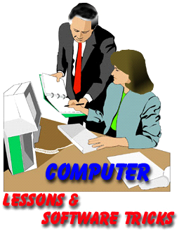
Description: | Can use the internet for information

Files Required
Suitable for Classes: | AIT • Multimedia • Cert II IT • Cert II Bus
Area: | Technology & Enterprise
Teacher: | Mr Peter Faulks
Timeline | 2 hours

Date Due:
Task Brief: | In class lesson

Outcomes:

Items highlighted in yellow are tasks for you to complete
Items in Blue italics are help tips

Operate personal computer Quiz

Peter Faulks, BA Soc Sci, Grad Dip Ed, Cert IV AWT

Computer Operating System - The Quiz

Save the work

Copy and paste into a new document called

Your_Initals Computer Operating Quiz

ANSWER ALL QUESTIONS

Section 1 Explain the following computer hardware components:

(Sentences please)

- Screen
Answer:
- Keyboard
Answer:
- Mouse
Answer:
- System Unit
Answer:
- Central Processing Unit
Answer:
- Memory
Answer:
- Sound Card
Answer:

2. Explain the following computer peripherals:

- A Printer is…
Answer:
- A Scanner is used to…
Answer:
- A Modem allows you to…
Answer:

- Explain the difference between a CD-R, CD-RW, DVD-R and DVD-RW
Answer:
- 4. Explain an Ergonomic principle to help avoid eye strain
Answer:
- 5. Explain an Ergonomic principle to help avoid physical strain.
Answer:
- 6. Describe the function of a computer operating system.
Answer:
- Describe the boot process.
Answer:
- What is the relationship between an application program, the operating system and hardware?
Answer:
- What are the general differences between the different computer platforms and their respective operating systems.
Answer:
- Draw a simple block diagram showing the interconnection of the various components of a computer.
Answer:

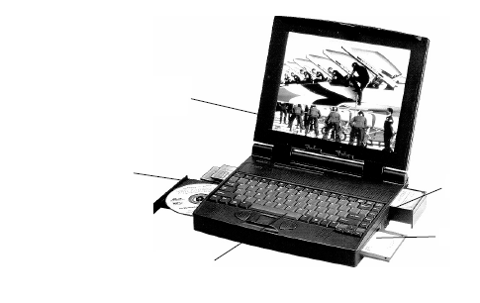
- Write the name of the external hardware components and peripherals on the following diagram
Answers:

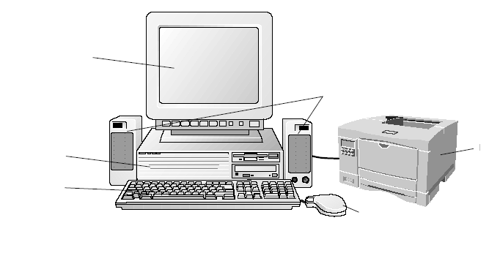
- Label the parts on these computers
Answers:
Use text boxes to line up your answers

- Describe the functions of computer hardware and associated OH&S standards and environmental considerations around hardware use and disposal of equipment

- Label each of the following as hardware or software.
Answer:
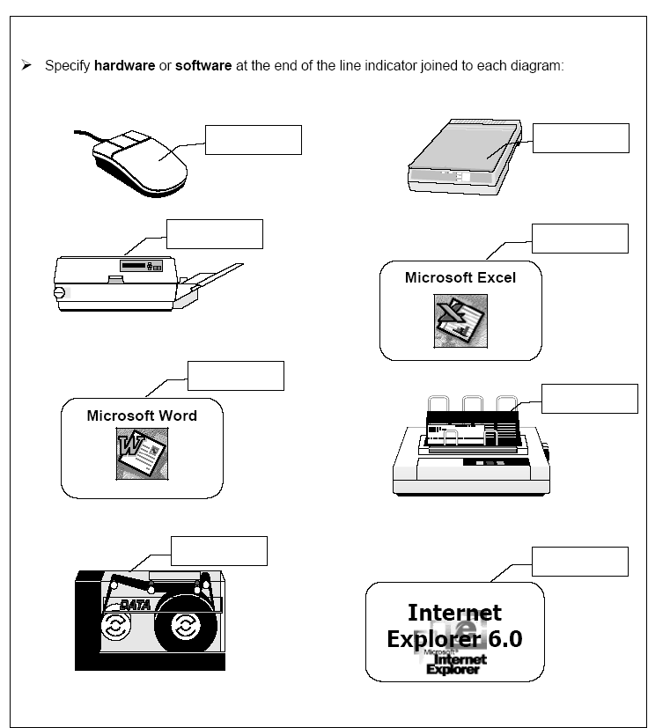
(Use text boxes)

---------------End of Copy and paste --------

